**First Day of Writing Diary. (Influenced by Prathamesh Patil)**

**Date: 12/03/2024**

Aaj Majha Diary lihaycha pahila divas ahe. ✌️😁. Majhya sobat ithe swataha, sakshat shree parabramha **Prathamesh Patil** baslele ahet. Ha amcha ek photo:

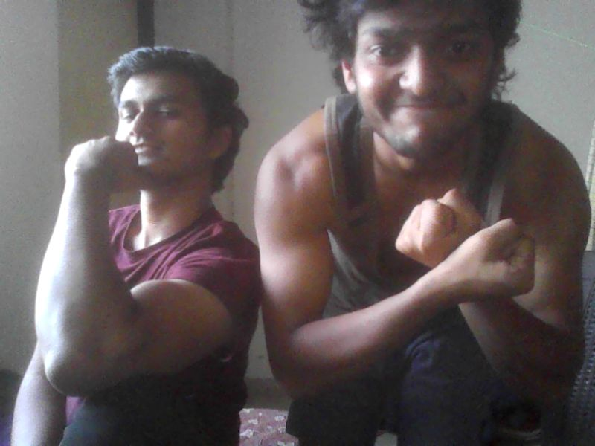

Ha Jo photo ahe ha mi online, eka website vr jaun kadhla ahe, karan majhya pc cha storage full jhala hota.

*He je mi lihila ahe , te khup deep ahe asa paddy bhau mhnatat ani tyancha mhanna ahe ki “****itka deep lihishil, tar koni vachnar nahi****” ata jya arthi tumhi vachta a tya arthi aple paddy bhau chukle asa mi consider karto.*  
jaudya soda. Pahila page ahe diary cha. udya pasun nakki nit lihito!

Jai Hind Jai Maharashtra. Radhe Radhe!